
Group Project
12/12/25

Expository Writing

The rise of Artificial Intelligence in Pakistan
Opportunities , Challenges and a Strategic Road Map for Software Engineers

SP25 – BSE – 010
SP25 – BSE – 013
SP25 – BSE – 082
SP25 - BSE – 091
SP25 - BSE – 094
SP25 – BSE - 106
Ahmed Ali Khan
Aizaz Noor
Athar Abbas
Moaz Nadeem
Naeem Akbar
Mukaram Nadeem

TABLE OF CONTENTS
INTORDUCTION 3
- Policy and Governance: Architecture of a Digital Nation
- The Economic Situation: Thriving in the Age of Dynamic Change.
- CHALLENGES 4
  - The Challenging Market for Junior Engineers
  - Technological and Infrastructure Constraints
  - Ethical Dilemmas and New Roles
  - Integrating AI in Legacy Code
  - AI-developed Code in Production
  - Cognitive Corrosion

OPPURTUNITIES 7
  - Sectoral Deep Dive: AI in Action
  - The Research and Innovation Ecosystem
  - AI Powered Software Development Life Cycle
  - AI in Software Testing
  - Integrating Security Into the DevOps Lifecycle
  - The Use of AI in Software Engineering
  - AI in Jobs

Strategic Roadmap for Software Engineers 10
- The "AI Alchemist" Tech Stack
- Career Pathways and Compensation
- Short, Medium, and Long-term Goals
- Tools & Techniques for Roadmap Execution
Conclusion 15
References 16
Challenges References: 16
Opportunities References: 16
Roadmap References: 16

The Rise of Artificial Intelligence in Pakistan: Opportunities, Challenges, and a Strategic Roadmap for Software Engineers

Table of Contents
- Introduction
- Policy and Governance: Architecture of a Digital Nation
- The Economic Situation: Thriving in the Age of Dynamic Change.
- Challenges
  - The Challenging Market for Junior Engineers
  - Technological and Infrastructure Constraints
  - Ethical Dilemmas and New Roles
  - Integrating AI in Legacy Code
  - AI-developed Code in Production
  - Cognitive Corrosion
- Opportunities
  - Sectoral Deep Dive: AI in Action
  - The Research and Innovation Ecosystem
  - AI Powered Software Development Life Cycle
  - AI in Software Testing
  - Integrating Security Into the DevOps Lifecycle
  - The Use of AI in Software Engineering
  - AI in Jobs
- Strategic Roadmap for Software Engineers
  - The "AI Alchemist" Tech Stack
  - Career Pathways and Compensation
  - Short, Medium, and Long-term Goals
  - Tools & Techniques for Roadmap Execution
- Conclusion
- References

Introduction
Artificial Intelligence (AI) is not a buzzword anymore but actually it is transforming how software is implemented. The conventional position of the software engineer is changing with the introduction of the super-powered softwares like ChatGPT and GitHub Copilot. This is a challenge and an opportunity to a developing IT country such as Pakistan. The major issue in the eyes of Pakistan as pointed out in recent industry reports is the absence of domestic AI models and the infrastructure needed to develop it.
By the end of 2025, Pakistan is going through a complicated change. The country, with a population of more than 240 million of which about 64 percent are below the age of 30 years, has the raw material on demographic front needed to give her a large digital dividend. Nonetheless, this possibility is now suddenly walled in by harsh structural issues. The emergence of Generative AI has already started to commodify simple coding procedures, and the Pakistani market has to resign to the idea that it has been adopting technology and start creating it.
In particular, this report speaks about the hurdles that Pakistani software engineers encounter. These are a challenging job market with juniors facing automation of basic coding, the technology gap in the form of the inability to make locally-based AI solutions, and the cognitive debt caused by over-dependence on AI solutions.
Strategic roadmap is a systematic plan that outlines career aims and milestones, and steps of development that a software engineer should follow in the process of career development. It is a proactive to prepare skills, experiences and objectives with professional development with the intention of progressing an engineer at the entry level up a technical and leadership ladder.
Purpose and Importance:
- Offers purpose and guidance and makes career choices informed.
- Promotes life long learning in order to remain relevant in the developing tech world.
- Supports performance improvement and smooth career advancement.

Through strategic roadmap, software engineers can build the applicable skills in a systematic fashion, compare themselves against the acceptable progress, and meet their individual objectives with the industry needs in order to achieve a long term career development and competitiveness.

Architecture of a Digital Nation Policy and Governance.
There cannot be a strong AI ecosystem where there is no strong legal and regulatory framework. Over the last two years, Pakistan’s policymakers have attempted to construct this framework.
The National Artificial Intelligence Policy 2025
The National Artificial Intelligence Policy has been operationalized by the ministry of information technology and telecommunication (MoITT) in 2025 after many years of deliberation. This report is the strategic roadmap of the country towards the digital future with a focus on human capital and ecosystem development. Key pillars include:
- AI Innovation Ecosystem: The creation of Centers of Excellence (CoE) to commercialise research.
- Market Enablement: A National AI Fund to fund startups and research.
- Awareness and Readiness: Inclusion of AI learning in national education.
The Digital Nation Pakistan Act 2024

Alongside the AI policy, there is the Digital Nation Pakistan Act 2024. This act constitutes the National Digital Commission and the Pakistan Digital Authority. One of the key ones is the so-called National Data Exchange Layer and the fact that government databases (such as NADRA and FBR) should be interoperable, to supply the scope of large-scale datasets that may be used to train local AI models.
The Economic Situation: Thriving in the Age of Dynamic Change.
The IT sector of the Pakistani economy is also progressive based on the economic indicators. The fiscal year ending June 2024 marked the highest remittance recorded in the history of IT exports, at close to 3.2 billion, and the trend is projected to go up in FY2025.
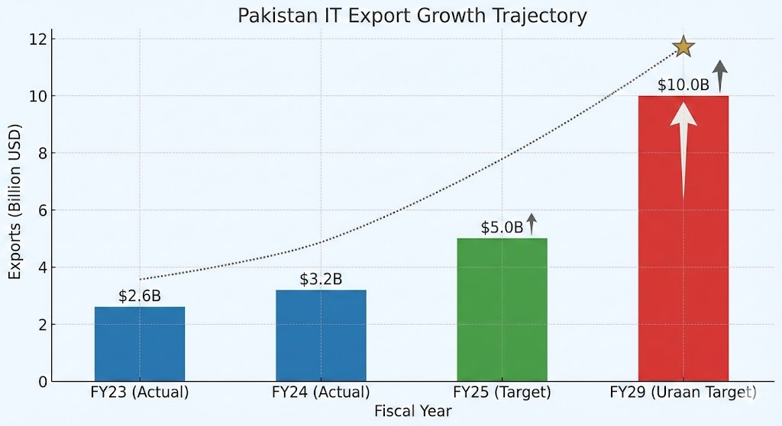
Figure 1 Source: Topline Securities / Arab News (2025)

Indicator | Metric/Status | Analysis
Annual IT Exports (FY24) | ~$3.2 Billion | Represents the highest-ever export figures, positioning IT as a top service export.
YoY Growth Rate | ~18% - 32.7% | Growth varies by quarter; recent data indicates a surge of 32.7% in early FY25.
Registered IT Companies | 10,000+ | Includes software houses, BPOs, and call centers registered with PSEB.
Freelancer Population | 2.37 Million+ | Pakistan ranks as the 3rd most popular country for freelancing globally.
Global Ranking | Top Tier Destination | Recognized as "Tech Destination of the Year" at GITEX Global 2024.
Infrastructure | 250+ STPs | A network of Software Technology Parks (STPs) is being expanded to tier-2 cities.

The Freelance Revolution
Pakistan remains the 3rd most popular country for freelancing globally. However, the market is bifurcating:
- The Commodity Tier: Upwork/Fiverr Freelancers that compete based on price (10 USD-20 USD/hour), can be automated by the AI.
- The Elite Tier: Very talented engineers relocated to managed remote work services like Crossover, with salaries that are much higher in compensation (2,000 -8,000/month).
The Startup Ecosystem
With a dry spell, the ecosystem experienced a resurgence during Q2 2025 with an investment amounting to $58 million with a significant portion of investments in Fintech (e.g., Haball) and Healthtech (e.g., MedIQ).

Challenges
Pakistan has its own obstacles that comprise market forces to lack of essential infrastructure. Junior Engineers in the Difficult Market.

The Challenging Market for Junior Engineers
Among the most immediate impacts of the AI upsurge, the automation of the entry-level jobs is highlighted. In the past, Pakistani junior engineers got into the industry undertaking the job of coding, bug fixes and testing. Nevertheless, more recent research shows that Generative AI has at least attained the ability to perform these jobs with growing speed and accuracy.

Automation of Routine Tasks
Ahmed et al. (2025) claim that the AI tools can now produce code, produce unit tests, and even code the logic behind the complex logic. This automation poses a risk to the olden day learning through doing route of the junior engineers. When a machine is capable of writing simple boilerplate code immediately, firms no longer have a reason to employ juniors in that particular task. This poses an even bigger obstacle to entry; now juniors should be able to have the architectural and problem-solving skills of middle level engineers before they can secure their first position.

The Risk of Cognitive Debt
The quality of skills that new engineers are acquiring is of concern as well. According to the research conducted by Kosmyna et al. (2025), an excessive dependence on AI as a writing and problem-solving tool causes cognitive debt. In cases where students/juniors rely on AI to create a code without comprehending the logic behind the code, they are not able to think critically and analyze the code in depth. This is hazardous in the learning system of Pakistan. When graduates use AI to complete their exams or complete their projects, they end up with the knowledge that is superficial, rendering them less relevant in occupations that are complex in nature (Kosmyna et al., 2025).

Technological and Infrastructure Constraints
Another significant problem of its own in Pakistan lies in the absence of sovereign or local AI technology. According to the observation in the local industry, we do not possess sufficient technology to create AI.

The Internet Stability Crisis
The IT industry can only survive with reliable internet connectivity. Nevertheless, the adoption of the nation-wide firewall (web management system) has led to serious collateral damage. In 2024, the economy suffered because of more than $1.62 billion due to internet outages and social media bans. In the case of freelancers, missed deadlines and negative reviews due to regular failures mean a loss of the brand image of the Pakistani talent.

The 5G Lag and Connectivity Deficit
While the world moves to 5G, Pakistan is lagging. The auction for 5G spectrum has been repeatedly delayed (tentatively April 2025). This forms a technology bottleneck; local developers are not able to readily create or test new generation applications (such as real time IoT) that demand 5G latency.

The Cost of Training Models
The foundational Large Language Models (LLMs) training needs vast numbers of computing units (GPUs) and large datasets. According to Ahmed et al. (2025), the amount of energy used and the cost of operations of these models are astronomical. In the case of software houses in Pakistan, it is a cost barrier to get access to the hardware necessary to train models (as opposed to run them). The result is the current reliance on foreign models (e.g, OpenAI or Google), which might not be geographically or culturally optimized (e.g to local languages in Urdu or regional dialects).

Data Quality and Bias
The quality of AI models is determined by the quality of data they are trained on. Majority of big models are trained on western-centric datasets. This brings biasness and lowers the efficiency of AI tools in the context of local Pakistani issues. Moreover, the problem of gathering large amounts of quality, unbiased data to train and train local models is a huge engineering problem that the local industry has not completely addressed (Ahmed et al., 2025).

Ethical Dilemmas and New Roles
Despite these obstacles, AI is not displacing software engineers, but it is transforming the task of software engineers.

Shift in Skill Sets
The position of a coder is turning to a systems architect or an AI product manager. Now engineers will have to study Prompt Engineering with the ability to control AI models in a manner that would give them the required results. According to Ahmed et al. (2025), the engineer of tomorrow will not write more syntax and will focus on AI-generated code more on its validation, maximize its security, and incorporate AI modules into larger systems.

Ethics and Security
Applications of AI can introduce some ethical threats, including copyright violation and the risk of exposing AI-written code to security threats. Pakistan companies should create a high level of standards to avoid unauthorized usage of information and provide that the AI-generated code would not lead to security violations (Ahmed et al., 2025).

Integrating AI in Legacy Code
An issue that the software industry is currently facing is integrating AI into legacy code. The systems built by previous developers are still standing and performing well, but now clients want AI tools in their products and services. Integrating AI into legacy systems is difficult as it can result in disruptions to the current workflow, slowdowns in development, and additional costs.

AI-developed Code in Production
When LLM-generated code is put into a production environment, it often breaks. It is bugged. Linus Torvalds - creator of Linux and Git - said in his recent interview that "I think vibe coding (a term for mindless programming directly through AI) is great for getting into programming, but I think it's going to be a horrible thing to maintain." In recent years, many companies have replaced human developers with AI tools. But a January 2024 survey on 1400 business executives found that 66% of executives were doubtful, and some were dissatisfied with their organization's progress on AI and GenAI. Although it's a bit outdated survey, there hasn't been any revolutionary change in AI in the recent two years. The following are some reasons why AI code fails in production:
- AI generates code in its own ecosystem. But there are several things code needs to take care of in production, that is legacy realities, service boundaries, data contracts and authorization middle ware, etc. And the challenge here is that communicating these complications to LLM is not so simple.
- Another problem with AI is that it lacks persistent understanding. It does not have enough context to resolve systems.

Cognitive Corrosion
A recent study by the MIT Media Lab says that relying too much on AI may lead to a measurable decrease in learning skills, critical engagement, and neural activity. Some students often get the whole task done by A.I would rather take some help from it or collaborate. Using very little of their own cognitive functions. It enhances laziness and procrastination. As a student's work is being done in mere seconds with a single prompt. They neither verify nor evaluate the LLM’s output. For that matter, they don't even have the expertise to evaluate A.I.
These consequences extend beyond the classroom. Students who have studied in this environment may face difficulty landing a job, as the skills required by many roles, such as critical thinking and creativity, can be diminished due to the overuse of AI tools. It is important for students to realize that submitting assignments is not the ultimate goal. The key is the learning gained while solving problems.

Opportunities

Moving beyond the challenges, AI is being deployed to solve existential problems in specific sectors, creating massive opportunities for innovation. Sectoral Deep Dive: AI in Action

Sectoral Deep Dive: AI in Action
1. Agriculture (AgriTech):
AI is intervening to bridge the gap of yields.

- Cowlar: It is an observational device that can track the well-being and estrus behaviors of the herd on dairy cattle to increase production levels by using smart collars.
- Farmonaut: It is based on satellite data and is used to do targeted farming to track water stress and fertilizer requirements.
2. Healthcare (HealthTech):
The AI is assisting in closing the gap of doctor shortage. The National Center of Artificial Intelligence (NCAI) has created localized trends of AI in radiology, recognizing TB in the base X-rays with 98 percent rate and detecting brain tumors.

3. Fintech:
Financial industry is being digitalized. Systems Limited collaborated with Temenos to upgrade the State Bank of Pakistan core banking platform. SadaPay and NayaPay are some of the fintechs that onboard the unbanked population using AI-based identification, which is electronic KYC.
4. Industrial Automation:
The textile Industry is progressing to use AI-based quality control (computer vision) to identify a defect in the fabrics. This however is dangerous since 60 percent of the labor force in labor jobs risk losing their jobs.
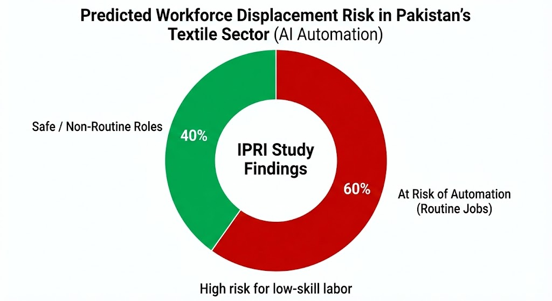

The Research and Innovation Ecosystem
The academic ecosystem of Pakistan is a fully working generator of AI knowledge.

- Bibliometric Trends: Deep Learning and Computer Vision Deep Learning and Computer Vision Research is highly concentrated, with NUST dominating productivity.

- Niche Breakthrough (Urdu OCR): The architectures Training CNNs with large-scale datasets Specially CNNs have been trained to recognize pure handwritten Urdu characters with a very high precision of over 98.3. This is a major indigenous input.

- Key Labs: National Center of Artificial Intelligence (NCAI), Deep Learning Lab (DLL) at NUST and Intelligent Machines Lab at ITU are main hubs

AI Powered Software Development Life Cycle
Brute (2025) provided a thorough analysis of how AI can be used to complement the whole software development life cycle, beginning with requirements collection and enumeration up to designing, development, testing, implementation, maintenance, and upkeep. As explained in the paper, AI may automate requirements and analysis, produce architecture suggestions and support developers with code suggestions and documentation. It also shows key potentials in automated test-case generation, savvy CI/CD pipelines and proactive upkeep with the aid of log and performance information analysis. Brute claims that the implementation of AI into every SDLC step will produce a faster development process, a reduced number of errors and systems that are easier to maintain, and eventually makes the process of traditional engineering smarter and more adaptive.

AI in Software Testing
The journal: algorithms (MDPI,2025) addresses 10 years of development of using artificial intelligence to test software. The authors group AI methods employed in defect detection, generation of test cases, automated test execution and optimization of testing plans. This paper discloses that AI guided testing is effective in terms of coverage, manual load reduction and accuracy in predictions of high risk areas in the code. It also suggests a taxonomy which demonstrates the applicability of other AI subfields like machine learning, deep learning, evolutionary algorithms; to the different stages of testing. As it is concluded, AI driven testing is a significant possibility to enhance the reliability of software and reduce the release time.
.

Integrating Security Into the DevOps Lifecycle with AI and Automation
Thopalle (2024) explores the possibility to implement the practice of artificial intelligence into the sphere of DevSec by integrating automated security analysis into the DevOps pipeline. The paper provides potential areas of utilization in which AI is able to notice weaknesses earlier, automate compliance verification, and anticipate probable deployment crashes. It also demonstrates that AI enhances constant surveillance through the analysis of logs, detection of abnormalities, and propose corrective measures. The paper proposes that software integrity, reduction of human error, and resilience of current software systems are positively augmented when DevOps automation is combined with AI-based security.

The Use of AI in Software Engineering
Kokol (2024) engages in a massive synthesis of recent sources that research the application of artificial intelligence at many stages of software engineering. The review reveals the main areas of opportunities which AI can be of great benefit: requirements engineering with the use of natural language processing, machine learning with predicting defects and estimating efforts, and deep learning with understanding and documenting codes. Another important point of the study is the increasing importance of AI in controlling software development lifecycle such as project planning, risk assessment, and repository mining towards better maintainability. Altogether, the paper points to the fact that AI is extending its reach to all spheres of software engineering rapidly, providing an opportunity to automate and enhance accuracy and make decisions based on data.

AI in Jobs
Repetitive codes are eliminated AI way, the reason is that higher positions are in demand such as:
- Machine Learning Engineers
- MLOps Engineers
- AI Software Architects
- Data Engineers
- AI Security Engineers
- Prompt Engineers
- AI Product Managers
- Growth Data
[Insert Table/Chart: Job Growth Stats - McKinsey 40-60% growth, Indeed 70% growth]
What AI Automates: Code suggestion, test generation, documentation, small bug fixes, code formatting.
The things that AI cannot handle AI cannot handle system architecture, would require multi-team awareness, reason about business logic, debugging complex systems, design that prioritizes humans, ethical decision-making, anything security-related.

Strategic Roadmap for Software Engineers

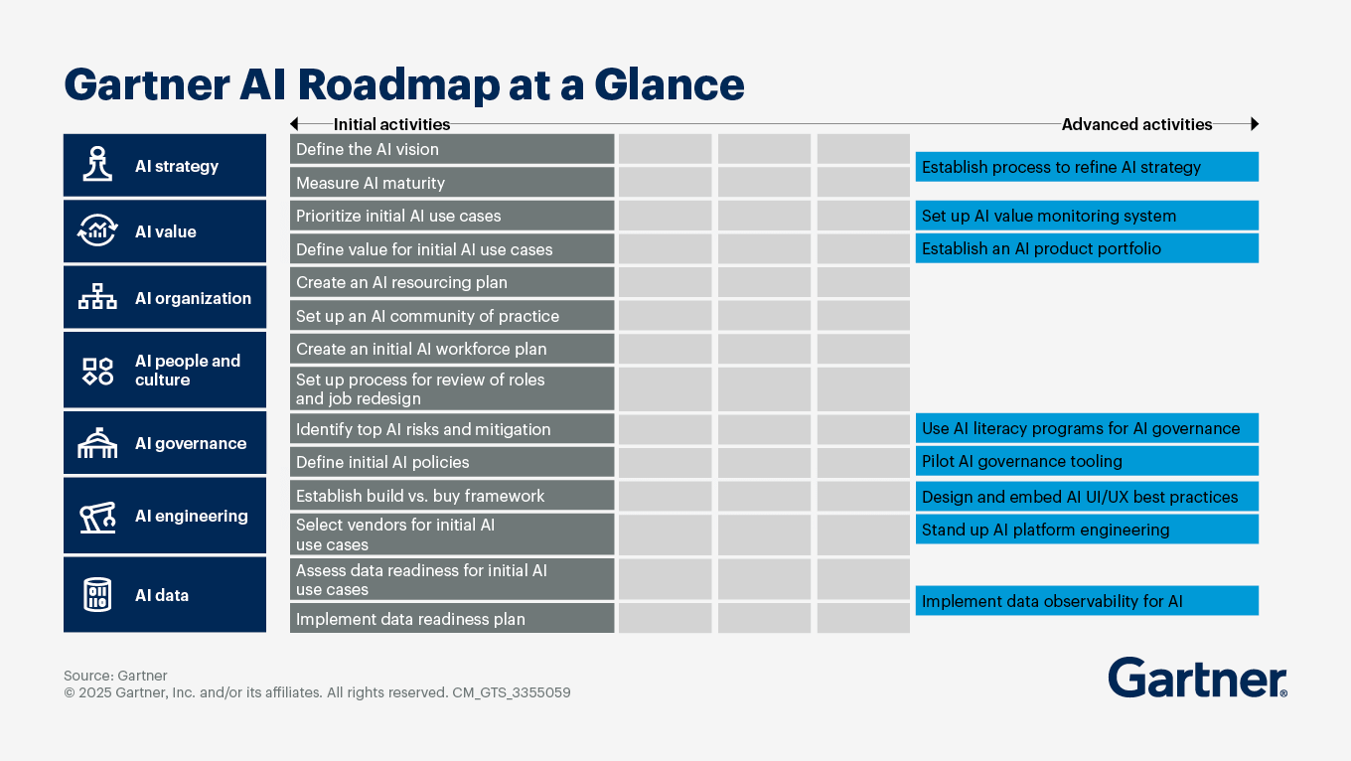

The "AI Alchemist" Tech Stack
Engineers will have to develop into an AI Alchemist professional with a mix of fundamental engineering or AI functionality.
[Insert Table: Essential Tech Stack for Pakistani AI Engineers (2025) - listing Python, RAG, YOLO, etc.]
Generative AI: RAG, LangChain, Vector DBs (Connecting theLLMs to personal data, developing applications).
- Computer Vision: YOLO (v8), openCV (in AgriTech and Smart Cities).
- Cloud/DevOps: Docker, Kubernetes, AWS SageMaker.
- Niche: Urdu NLP / Nastaliq OCR for government digitization.
Occupational Initiatives and Pay
The levels of the market should be in gear with the engineers:

[Insert Table: Compensation Disparity in Pakistan's Tech Sector (2025)]
- Local Enterprise (Systems Ltd, 10Pearls): Long-term, heavy-mentoring. Salary: PKR 150k - 400k+.
- High-End Remote (Crossover, Toptal): Global wages under pressure. Salary: $2,000 - $8,000 (PKR 500k - 2.2M).
- Freelance & Startup: Extremely risky, extremely rewarding. Specialized AI rates: $30-$60/hr.

Short-term Goals (0-2 years)
Pay attention to the creation of a solid base of technical and professional skills. Learn high level programming languages and have practical experience. Build professional profile in such sites as GitHub.

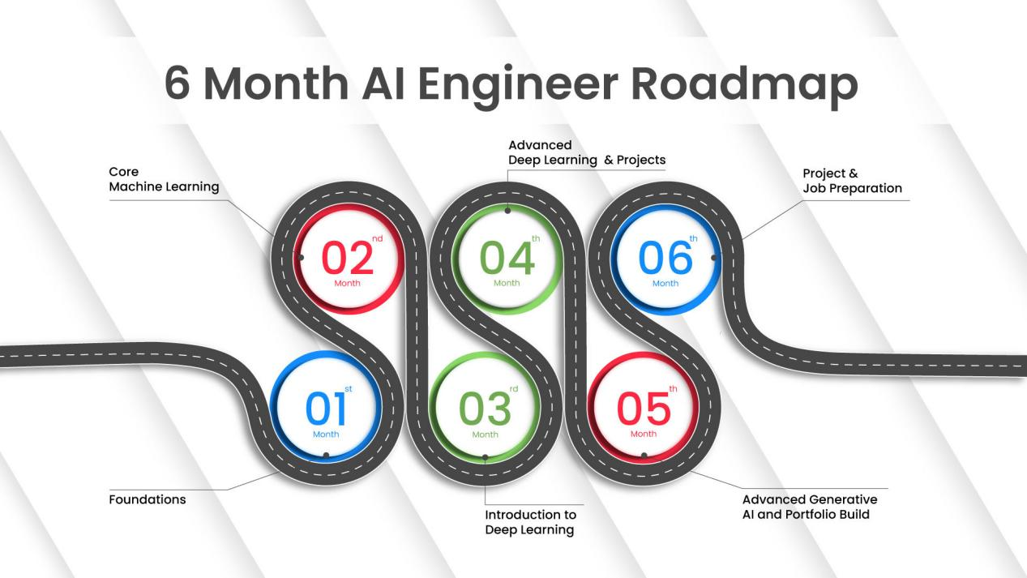

Medium-term Goals (2–5 Years)
Specialization skills: (System Design, Cloud Computing, AI/ML) and leadership skills. Head small teams and guarantee the quality of the code.

Long-term Goals (5+ Years)
Majority emphasis is on top management, corporate impact and invention. Acquire the roles of architects and participate in organizational decision making.
Resources and methods of roadmap implementations.
It needs to be implemented efficiently and thus, planning tools (Trello, Jira), learning platforms (Coursera, Udemy, PIAIC), and systems to track progress (self-assessment, mentor feedback).

Conclusion
The introduction of AI has become a life-threatening phenomenon to the software engineering sector in Pakistan. The tension comes with the state trying to offer the same level of infrastructure, namely internet consistency and 5G, whereas the spit is offered by the private sector: freelancers, startups, and researchers making a breakthrough such as Urdu OCR.
The information has substantiated the fact that the IT sector has become the most promising economic frontier in the country, with exports of the same increasing beyond 3 billion. Nonetheless, affordable access to the Internet has to be solved and there should be an all-out campaign to bridge the gender gap to bring about the vision of a Digital Nation.
Junior developers too are not finding the market favourable as they are currently being rotated out by automation in executing their normal tasks. In addition to this, the reality that the area lacks infrastructures to produce indigenous AI models renders a person dependent on technology of other nations. Minimum of this will mean that Pakistani engineers will have to go beyond rudimentary coding to survive. They should be consuming with the developed system design, AI ethics and those sectors where machines have not yet replaced human decision. The education systems also need to be flexible to allow students not to fall into the trap of cognitive debt by overdepending on AI tools.
To the software engineer the way out is nothing short of ruthless specialization. The generalist web developer is a byword. The future is those who will restrain the interception of domain knowledge and sophisticated AI engineering domain knowledge and transition to high-value skills such as RAG, Computer Vision and MLOps to stabilize their financial future.

References
- Ahmed, I., et al. (2025). Artificial intelligence for software engineering: The journey so far and the road ahead. ACM Transactions on Software Engineering and Methodology, 34(5), Article 119.
- Aalpha Information Systems. (2025). Offshore software development rates by country & region.
- Advance Social Science Archive Journal. (2025). Vol. 04 No. 02. October-December 2025.
- Ahmed, I., et al. (2025). Artificial intelligence for software engineering: The journey so far and the road ahead. ACM Transactions on Software Engineering and Methodology, 34(5), Article 119.
- Arab News. (2025, October). Pakistani IT bodies urge government to address slow Internet issue amid reports of economic losses.
- Arab News. (2025). Pakistan, UAE agree to boost cooperation in AI, digital governance at GITEX Global 2025.
- Biometric Update. (2025, February 18). Pakistan expands biometric data collection in telecom sector.
- Business Recorder. (2025). Pakistan's first-ever 5G auction: Decisions to be finalised by SAC today.
- Butt, S. (2025). Resume. [Curriculum Vitae].
- Burte, S. (2025). AI-Powered Software Development Life Cycle: From Requirements to Maintenance. AI Systems Engineering.
- Chinook Strategy. (2025). Pakistan's software export board: A legacy trap in the AI era. Musings.
- Crossover. (2025). Compensation. Crossover Reviews.
- Crossover. (2025). Reviews. Crossover.
- CVFormat. (2025). Continuous Learning in Software Engineering.
- DevToLead. (2025). Strategic Roadmaps for Engineers.
- Farmonaut. (2025). Autonomous agricultural machinery company in Pakistan 2025.
- GitHub. (2024). Developer Productivity Report.
- Higher Education Commission (HEC). (2024). Draft framework on use of Generative AI (GenAI) tools in Higher Education Institutes (HEIs).
- Higher Education Commission (HEC). (2025). Revised curriculum for degree programs in computer science.
- HEC Digital Library. (2023). Professional Development Resources.
- Himalayas. (2025). Haseeb Ul Hassan - Junior machine learning engineer. VisionX.
- IAEME. (2023). Mentorship in Engineering.
- Indeed Hiring Lab. (2023–2025). Job postings for AI and ML engineers.
- IEEE Xplore. (2024). Edge ML technique for smart traffic management in intelligent transportation systems.
- IJRCAIT. (2023). Role Transition & Leadership in Software Engineering.
- International Science Council. (2025). Pakistan: AI paper case study.
- Invest2Innovate. (2025). The fintech landscape in Pakistan: Progress and potential.
- JSTOR. (2022). Emerging Technologies in Software Engineering.
- Kokol, P. (2024). The Use of AI in Software Engineering: A Synthetic Knowledge Synthesis of the Recent Research Literature. Information, 15(6).
- Kosmyna, N., et al. (2025). Your brain on ChatGPT: Accumulation of cognitive debt when using an AI assistant for essay writing tasks. MIT Media Lab.
- Law and Policy Review (LPR). (2025). Human rights and the era of generative artificial intelligence.
- Linus Torvalds. (2025). Interview on AI Code. YouTube.
- McKinsey. (2024). Demand for AI-related engineering roles.
- MDPI. (2023). Algorithms and Software Engineering.
- MDPI. (2025). ChatGPT research: A bibliometric analysis based on the Web of Science from 2023 to June 2024.
- MEA Tech Watch. (2024, November 12). Pakistan to launch 5G internet service by April 2025, PTA announces.
- Ministry of Information Technology & Telecommunication (MoITT). (2025). National artificial intelligence policy.
- Ministry of Information Technology & Telecommunication (MoITT). (n.d.). Pakistan's IT industry overview.
- National University of Sciences and Technology (NUST). (2025). Deep and reinforcement learning lab.
- NewsThink. (2025). AI Code Doesn't Survive in Production: Here's Why. The New Stack.
- Nucamp. (2025). The complete guide to using AI in the healthcare industry in Pakistan in 2025.
- Pakistan Software Export Board (PSEB). (2025). Pakistan tech destination of the year.
- Pakistan Software Export Board (PSEB). (2025). PSEB annual report.
- Payscale. (2025). Average software engineer salary in Pakistan.
- PLOS One. (2025). Application of deep learning in behavior recognition and early warning system for campus safety management.
- Presidential Initiative for Artificial Intelligence & Computing (PIAIC). (2025). Merit list.
- Project MUSE. (2022). Strategic Planning in Technology.
- PwC Australia. (2025). Solving problems with smart agriculture and precision farming.
- Reddit. (2025). Salaries in Pakistan. r/pakistan.
- RemotePass. (2025). Global contractor rates in 2025: Country-by-country comparison.
- Resumly. (2025). Career Growth for Software Engineers.
- ResearchGate. (2025). A convolutional neural network based optical character recognition for purely handwritten characters and digits.
- ResearchGate. (2025). Bibliometric analysis of information and communication technology research in Pakistan.
- SAMENA Daily News. (2025). 5G internet service in Pakistan by April 2025.
- ScienceDirect. (2023). Technical Skills for Software Engineers.
- Systems Limited. (2025). State Bank of Pakistan partners for core banking upgrade.
- The Nation. (2025, May 2). AI-driven farming crucial for Pakistan's climate resilience, food security: Experts.
- Thopalle, P. K. (2024). DevSecOps: Integrating Security Into the DevOps Lifecycle with AI and Automation. IJARET, 15(3).
- Tracxn. (2025). Cowlar: 2025 company profile, team, funding & competitors.
- United Nations Development Programme (UNDP). (2025). DAP Volume 12, Issue 1: Artificial intelligence.
- University of Peshawar. (2025). Annexure-B: Curriculum for BS Artificial Intelligence.
- Yasir, F., & Kazmi, M. (2025). Acceleration of Urdu optical character recognition on Zynq UltraScale+ MPSoC using deep CNN. IEEE Xplore.

